Sam McDowell

7/10/2020

Lab 4-1.4

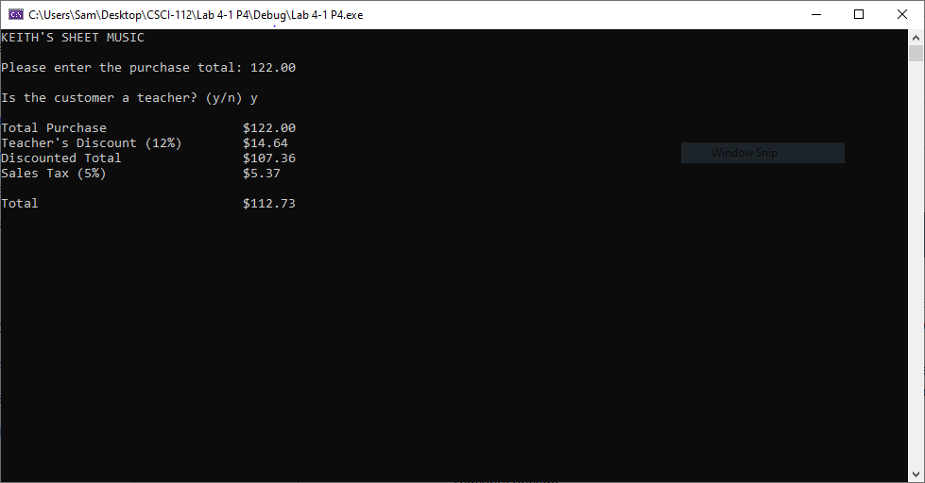

# Transcription:

KEITH'S SHEET MUSIC

Please enter the purchase total: 122

Is the customer a teacher? (y/n) y

Total Purchase $122.00

Teacher's Discount (12%) $14.64

Discounted Total $107.36

Sales Tax (5%) $5.37

Total $112.73